PROGRAM NO: 1 DATE: 3/06/26
#TO CHECK A PRIME NUMBER BY USING FUNCTION
SOURCE CODE
def Prime(num):
count = 0
for i in range(1, num + 1):
if num % i == 0:
count += 1
return count

number = int(input("Enter a number: "))
result = Prime(number)

if result == 2:
print(number, "is a prime number")
else:
print(number, "is not a prime number")

OUTPUT:
Enter a number:37
37 is a prime number

Enter a number:46
46 is not a prime number

PROGRAM NO: 2 DATE: 5/06/26
#TO DISPLAY FIBONACCI SERIES USING FUNCTION
SOURCE CODE
def Fibonacci(n):
Result = []
s = 0
k = 1

while s <= n:
Result.append(s)
c = s + k
s = k
k = c

return Result

n = int(input("Enter value of n: "))
f = Fibonacci(n)

print("Fibonacci Series up to", n, ":")
print(f)

OUTPUT:
Enter value of n:100
Fibonacci Series upto 100 :
[0, 1, 1, 2, 3, 5, 8, 13, 21, 34, 55, 89]

PROGRAM NO: 3 DATE: 16/06/26
#TO CHECK A PALINDROME WORD BY USING FUNCTION
SOURCE CODE
def palin(a):
if a == a[::-1]:
return 1
else:
return 0

a = input("Enter a word in uppercase: ")

b = palin(a)

if b == 1:
print("Palindrome word")
else:
print("Not a Palindrome word")
OUTPUT
Enter a word in uppercase: SUZUKI
Not a Palindrome word
Enter a word in uppercase: MALAYALAM
Palindrome word

PROGRAM NO: 4 DATE: 16/06/26
#TO COUNT THE NUMBER OF VOWELS PRESENT IN A STRING BY USING FUNCTION
SOURCE CODE
def vowel(a):
b=0
for i in a:
if i in "aeiouAEIOU":
b=b+1
print("Number of vowels:", b)

a = input("Enter a string: ")
vowel(a)

OUTPUT
Enter a string: Hello World
Number of vowels: 3

PROGRAM NO: 5 DATE: 22/06/26
#WRITE A PROGRAM TO CHANGE EVEN NUMBERS TO “*” IN A LIST USING FUNCTION
SOURCE CODE
def change(a):
for b in range(len(a)):
if a[b] % 2 == 0:
a[b] = "*"
return a

a = []
b = int(input("Enter the number of elements: "))

for c in range(b):
d = int(input("Enter element: "))
a.append(d)
print("Original List:", a)
print("Modified List:", change(a))
OUTPUT
Enter the number of elements: 5
Enter element: 12
Enter element: 15
Enter element: 8
Enter element: 21
Enter element: 10
Original List: [12, 15, 8, 21, 10]
Modified List: ['*', 15, '*', 21, '*']

PROGRAM NO: 6 DATE: 29/06/26
#WRITE A PROGRAM TO FIND THE DIFFERENCE
BETWEEN GREATEST AND SMALLEST NUMBER IN A LIST
SOURCE CODE
def differ(x):
s=x[0]
b=x[0]
for i in range(len(x)):
if x[i]:
s=x[i]
if x[i]:
b=x[i]
d=b-s
print("difference=",d)

limit =int(input("enter the no. of elements"))
lst1=[0]*limit
print("Enter the eleements")
for j in range(limit):
lst1[j]=int(input())
print("The the list is ",lst1)
differ(lst1)
OUTPUT
Enter the number of elements: 5
Enter the elements:
10 25 3 18 7
The list is: [10, 25, 3, 18, 7]
Difference = 22
PROGRAM NO: 7 DATE: 4/07/26
WRITE A RANDOM NUMBER GENERATOR THAT GENERATEST RANDOM NUMBERS BETWEEN 1&6.
SOURCE CODE
import random
print("*********** Simulating a Dice ***********")
while True:
a = random.randint(1, 6)
if a == 6:
print("Wow! You got:", a)
print("Take your turn and start the game!!!")
else:
print("Your number is:", a)
b = input("Want to roll again? (Enter Y/N): ")
if b == 'N' or b == 'n':
break
print("Thanks for playing!!!")
OUTPUT
*********** Simulating a Dice ***********
Your number is: 3
Want to roll again? (Enter Y/N): Y
Wow! You got: 6
Take your turn and start the game!!!
Want to roll again? (Enter Y/N): Y
Thanks for playing!!!

PROGRAM NO: 8 DATE: 9/07/26
#WRITE A PYTHON PROGRAM TO ILLUSTRATE THE USE OF BUILT IN FUNCTIONS USING RANDOM FUNCTION
SOURCE CODE
import random

# Generate a random float between 0.0 (inclusive) and 1.0 (exclusive)
print(f"Random float: {random.random()}")

# Generate a random integer between a and b (inclusive)
print(f"Random integer between 1 and 10: {random.randint(1, 10)}")

# Generate a random integer from a range (start, stop, step)
print(f"Random integer from range(0, 10, 2): {random.randrange(0, 10, 2)}")

# Generate a random float within a specified range [a, b]
print(f"Random float between 5.5 and 10.5: {random.uniform(5.5, 10.5)}")
OUTPUT
Random float: 0.7345829104
Random integer between 1 and 10: 7
Random integer from range(0, 10, 2): 4
Random float between 5.5 and 10.5: 8.92645321

PROGRAM NO: 9 DATE: 14/07/26
#TAKE A STRING AS ARUGUMENT & COUNT THE NUMBER OF VOWELS &CONSONANTS IN IT
SOURCE CODE

def count(s):
v=0
c=0
for i in s:
if i.isalpha():
if i.lower() in "aeiou":
v+=1
else:
c+=1
print("Vowels =",v)
print("Consonants =",c)

s=input("Enter a string: ")
count(s)

OUTPUT
Enter a string: Hello World
Vowels = 3
Consonants = 7

PROGRAM NO: 10 DATE: 17/07/26
#TAKE A STRING AS AN ARGUMENT AND REPLACE ITS ALPHABETS TO LOWERCASE
SOURCE CODE
def small(s):
result = ""
for i in s:
result += i.lower()
print(result)

s = input("Enter a string: ")
small(s)

OUTPUT
Enter a string: HELLO WORLD
hello world

PROGRAM NO: 11 DATE: 20/07/26
# PROGRAM TO FIND “THE” OR “the” IN THE STRING
SOURCE CODE
def count(s):
a=s.split()
c=0
for i in a:
if i=="The" or i=="the":
c+=1
print(c)

s=input("Enter a string: ")
count(s)

OUTPUT
Enter a string: The cat is on the mat
2

PROGRAM NO: 12 DATE: 23/07/26
# TO DISPLAY MINIMUM AND MAXIMUM OF A LIST
SOURCE CODE

def maxmin(a):
print("Maximum =",max(a))
print("Minimum =",min(a))

a=list(map(int,input("Enter numbers: ").split()))
maxmin(a)
OUTPUT
Enter numbers: 10 25 3 18 7
Maximum = 25
Minimum = 3

PROGRAM NO: 13 DATE: 27/07/26
#FUCTION THAT TAKES A LIST AND COUNT NO OF +VE AND –VE NUMBER IN THE LIST
SOURCE CODE
def count(a):
p=0
n=0
for i in a:
if i>0:
p+=1
elif i<0:
n+=1
print("Positive =",p)
print("Negative =",n)

a=list(map(int,input("Enter numbers: ").split()))
count(a)

OUTPUT
Enter numbers: 10 -5 8 -2 0 15
Positive = 3
Negative = 2

PROGRAM NO:14 DATE: 4/08/26
# FUCTION THAT TAKES A LIST OF STRING AND DISPLAY THE STRING THAT STARTS WITH ‘A’ ‘OR’ a
SOURCE CODE
def show(a):
for i in a:
if i[0]=="A" or i[0]=="a":
print(i)

a=input("Enter words: ").split()
show(a)

OUTPUT
Enter words: Apple Banana Ant Cat Apricot
Apple
Ant
Apricot

PROGRAM NO:15 DATE: 17/07/26
# PROGRAM TO CHECK WHETHER A MONUMENT EXISTS IN A DICTIONARY AND ADD IT IF ABSENT
SOURCE CODE
def check(a,b):
if a in b:
print("Present")
else:
l=input("Enter location: ")
b[a]=l
print(b)
d={"Taj Mahal":"Agra","Qutub Minar":"Delhi","Gateway of India":"Mumbai"}

a=input("Enter monument: ")
check(a,d)
OUTPUT
Enter monument: Taj Mahal
Present
Enter monument: Red Fort
Enter location: Delhi
{'Taj Mahal': 'Agra', 'Qutub Minar': 'Delhi', 'Gateway of India': 'Mumbai', 'Red Fort': 'Delhi'}

PROGRAM NO: 16 DATE: 20/07/26
# PYTHON IN STACK
# WRITE A PYTHON PROGRAM TO CREATE A STACK OF INTEGERS USING A LIST. IMPLEMENT PUSH, POP AND PEEK OPERATIONS.
SOURCE CODE
stack = []
def push():
n = int(input("Enter a number: "))
stack.append(n)
print(n, "pushed into the stack.")
def pop():
if stack == []:
print("Stack Underflow!")
else:
print("Popped element:", stack.pop())
def peek():
if stack == []:
print("Stack is empty.")
else:
print("Top element:", stack[-1])
while True:
print("\n1. PUSH")
print("2. POP")
print("3. PEEK")
print("4. DISPLAY")
print("5. EXIT")
ch = int(input("Enter choice: "))
if ch == 1:
push()
elif ch == 2:
pop()
elif ch == 3:
peek()
elif ch == 4:
print("Stack:", stack)
elif ch == 5:
break
else:
print("Invalid choice!")
OUTPUT
1. PUSH
2. POP
3. PEEK
4. DISPLAY
5. EXIT
Enter choice: 1
Enter a number: 10
10 pushed into the stack.
Enter choice: 1
Enter a number: 20
20 pushed into the stack.
Enter choice: 1
Enter a number: 30
30 pushed into the stack.
Enter choice: 4
Stack: [10, 20, 30]
Enter choice: 3
Top element: 30
Enter choice: 2
PROGRAM NO:17 DATE: 23/07/26
# PYTHON IN STACK
# “A WEB BROWSER STORES THE RECENTLY VISITED WEB PAGES IN A STACK. WRITE A PYTHON PROGRAM USING A LIST TO IMPLEMENT THE FOLLOWING OPERATIONS:”VISIT A NEW WEBPAGE – PUSH,GO BACK TO THE PREVIOUS WEBPAGE – POP,DISPLAYTHECURRENT WEBPAGE – PEEK
SOURCE CODE
def visit():
page = input("Enter webpage URL: ")
history.append(page)
print("Page visited:", page)
def back():
if len(history) == 0:
print("No previous page available.")
else:
print("Going back from:", history.pop())
def current_page():
if len(history) == 0:
print("No webpage available.")
else:print("Current webpage:", history[-1])
while True:
print("\nBROWSER HISTORY")
print("1. Visit Page")
print("2. Back")
print("3. Current Page")
print("4. Exit")
ch = int(input("Enter choice: "))
if ch == 1:
visit()
elif ch == 2:
back()
elif ch == 3:
current_page()
elif ch == 4:
break
else:
print("Invalid choice!")
OUTPUT
BROWSER HISTORY
1. Visit Page
2. Back
3. Current Page
4. Exit
Enter choice: 1
Enter webpage URL: www.google.com
Page visited: www.google.com
Enter choice: 1
Enter webpage URL: www.youtube.com
Page visited: www.youtube.com
Enter choice: 1
Enter webpage URL: www.wikipedia.org
Page visited: www.wikipedia.org
Enter choice: 3
Current webpage: www.wikipedia.org
Enter choice: 2
Going back from: www.wikipedia.org
Enter choice: 3
Current webpage: www.youtube.com
Enter choice: 4
PROGRAM NO:18 DATE: 24/08/26
# PYTHON IN STACK
# WRITE A PYTHON PROGRAM TO IMPLEMENT A STACK USING A DICTIONARY TO STORE STUDENT DETAILS. EACH STUDENT RECORD SHOULD CONTAIN ROLL NUMBER, NAME AND MARKS.
SOURCE CODE
stack = {}
top = -1
def push():
global top
roll = int(input("Enter Roll Number: "))
name = input("Enter Name: ")
marks = float(input("Enter Marks: "))
top = top + 1
stack[top] = {"RollNo": roll,"Name": name,"Marks": marks }
print("Student record pushed successfully.")
def pop():
global top
if top == -1:
print("Stack Underflow!")
else:
print("Deleted record:")
print(stack[top])
del stack[top]
top = top - 1
def display():
if top == -1:
print("Stack is empty.")
else:
print("\nStudent records in Stack:")
for i in range(top, -1, -1):
print(stack[i])
while True:
print("\n1. PUSH")
print("2. POP")
print("3. DISPLAY")
print("4. EXIT")
ch = int(input("Enter choice: "))
if ch == 1:
push()
elif ch == 2:
pop()
elif ch == 3:
display()
elif ch == 4:
break
else:
print("Invalid choice!")

OUTPUT
1. PUSH
2. POP
3. DISPLAY
4. EXIT
Enter choice: 1
Enter Roll Number: 101
Enter Name: Rahul
Enter Marks: 85.5
Student record pushed successfully.
Enter choice: 1
Enter Roll Number: 102
Enter Name: Anu
Enter Marks: 92
Student record pushed successfully.
Enter choice: 1
Enter Roll Number: 103
Enter Name: Arun
Enter Marks: 78.5
Student record pushed successfully.
Enter choice: 3
Student records in Stack:
{'RollNo': 103, 'Name': 'Arun', 'Marks': 78.5}
{'RollNo': 102, 'Name': 'Anu', 'Marks': 92.0}
{'RollNo': 101, 'Name': 'Rahul', 'Marks': 85.5}
Enter choice: 2
Deleted record:
{'RollNo': 103, 'Name': 'Arun', 'Marks': 78.5}
Enter choice: 3
Student records in Stack:
{'RollNo': 102, 'Name': 'Anu', 'Marks': 92.0}
{'RollNo': 101, 'Name': 'Rahul', 'Marks': 85.5}
Enter choice: 4

PROGRAM NO: 19 DATE: 30/08/26
#“WRITE A PYTHON PROGRAM TO CREATE A TEXT FILE NAMED STORY.TXT, WRITE A FEW LINES ENTERED BY THE USER INTO IT, AND THEN READ AND DISPLAY THE CONTENTS OF THE FILE ON THE SCREEN.”
SOURCECODE
def create_file():
with open("story.txt", "w") as file:
print("Enter 3 lines of text:")
for i in range(3):
line = input(f"Line {i+1}: ")
file.write(line + "\n")
print("File written successfully!\n")
def read_file():
print("--- Contents of story.txt ---")
with open("story.txt", "r") as file:
content = file.read()
print(content)
create_file()
read_file()
OUTPUT
Enter 3 lines of text:
Line 1: Once upon a time
Line 2: There was a beautiful village
Line 3: Everyone lived happily.
File written successfully!
--- Contents of story.txt ---
Once upon a time
There was a beautiful village
Everyone lived happily.

PROGRAM NO:20 DATE: 5/09/26

#“WRITE A PROGRAM TO READ A TEXT FILE LINE BY LINE AND DISPLAY EACH WORD SEPARATED BY A '#'.”
SOURCE CODE
myfile = open("Answer.txt", "r")
line = " "
while line:
line = myfile.readline()
for word in line.split():
print(word, end="#")
print()
myfile.close()
OUTPUT
Python#is#easy#
File#handling#is#useful#

PROGRAM NO:21 DATE: 8/09/26
#“PYTHON CODE FOR READING A TEXT FILE AND DISPLAYING THE TOTAL COUNT OF VOWELS, CONSONANTS, LOWERCASE LETTERS, AND UPPERCASE LETTERS.”
SOURCE CODE
def character_counts():
vowels_set = "aeiouAEIOU"
vowel_count = 0
consonant_count = 0
upper_count = 0
lower_count = 0
try:
with open("sample.txt", "r") as file:
content = file.read()
for char in content:
# Count uppercase and lowercase letters
if char.isupper():
upper_count += 1
elif char.islower():
lower_count += 1
# Count vowels and consonants (only for alphabetic characters)
if char.isalpha():
if char in vowels_set:
vowel_count += 1
else:
consonant_count += 1
# Display results
print("--- File Analysis Results ---")
print(f"Uppercase Letters : {upper_count}")
print(f"Lowercase Letters : {lower_count}")
print(f"Vowels : {vowel_count}")
print(f"Consonants : {consonant_count}")
except FileNotFoundError:
print("Error: The file 'sample.txt' was not found.")
character_counts()

OUTPUT
--- File Analysis Results ---
Uppercase Letters : 4
Lowercase Letters : 25
Vowels : 9
Consonants : 20

PROGRAM NO: 22 DATE: 11/09/26
#“PYTHON THAT READS A TEXT FILE NOTES.TXT AND COUNTS THE TOTAL NUMBER OF LINES STARTING WITH THE LETTER 'T' OR 'T'.”
SOURCE CODE
def count_lines():
t_count = 0
try:
with open("notes.txt", "r") as file:
lines = file.readlines()
for line in lines:
if line and line[0] in ("T", "t"):
t_count += 1
print(f"Total lines starting with 'T' or 't': {t_count}")
except FileNotFoundError:
print("Error: The file 'notes.txt' does not exist.")
count_lines()

OUTPUT
Total lines starting with 'T' or 't': 4

PROGRAM NO: 23 DATE: 14/09/26
# “PYTHON PROGAM TO READ LINES FROM A TEXT FILE ARTICLE.TXT AND DISPLAY ONLY THOSE WORDS WHOSE LENGTH IS LESS THAN 4 CHARACTERS.”
SOURCE CODE
def display_short_words():
try:
with open("article.txt", "r") as file:
content = file.read()
words = content.split()
print("Words with length less than 4:")
for word in words:
# Cleaning common punctuation attached to words
clean_word = word.strip(".,!?;:")
if len(clean_word) < 4:
print(clean_word, end=" | ")
print()
except FileNotFoundError:
print("Error: The file 'article.txt' does not exist.")
display_short_words()
OUTPUT
Words with length less than 4:
is | an | old | cat | It | can | run |

PROGRAM NO:24 DATE: 22/09/26
#“WRITE A PROGRAM TO READ CONTENT FROM SOURCE.TXT AND COPY ALL LINES THAT DO NOT CONTAIN THE WORD "REMOVE" INTO A NEW FILE DESTINATION.TXT”.
SOURCE CODE
def filter_and_copy():
try:
with open("source.txt", "r") as src, open("destination.txt", "w") as dest:
copied_count = 0
for line in src:
if "REMOVE" not in line:
dest.write(line)
copied_count += 1
print(f"Copy completed successfully! {copied_count} lines written to destination.txt.")
except FileNotFoundError:
print("Error: 'source.txt' was not found.")
filter_and_copy()
OUTPUT
Copy completed successfully! 3 lines written to destination.txt.
This is line 1.
This is line 3.
This is line 4.

PROGRAM NO:25 DATE: 25/09/26
# “WRITE A PYTHON PROGRAM TO APPEND NEW STUDENT RECORDS (NAME AND ROLL NUMBER) TO AN EXISTING TEXT FILE NAMED STUDENTS.TXT. THE PROGRAM SHOULD ASK THE USER HOW MANY RECORDS THEY WANT TO ADD, APPEND THEM WITHOUT OVERWRITING PREVIOUS DATA, AND THEN DISPLAY THE UPDATED FILE CONTENTS.”
SOURCE CODE
def append_student_records():
# Append mode ('a') opens file for writing at the end without truncating it
with open("students.txt", "a") as file:
n = int(input("How many student records do you want to append? "))
for i in range(n):
print(f"\n--- Student {i+1} ---")
roll_no = input("Enter Roll Number: ")
name = input("Enter Name: ")
file.write(f"Roll No: {roll_no} | Name: {name}\n")
print("\nRecords appended successfully!")
def display_records():
print("\n--- Updated Contents of students.txt ---")
try:
with open("students.txt", "r") as file:
content = file.read()
if content:
print(content, end="")
else:
print("File is empty.")
except FileNotFoundError:
print("Error: 'students.txt' does not exist yet.")
append_student_records()
display_records()

OUTPUT
How many student records do you want to append? 3
--- Student 1 ---
Enter Roll Number: 101
Enter Name: Anu
--- Student 2 ---
Enter Roll Number: 102
Enter Name: Rahul
--- Student 3 ---
Enter Roll Number: 103
Enter Name: Priya
Records appended successfully!
--- Updated Contents of students.txt ---
Roll No: 101 | Name: Anu
Roll No: 102 | Name: Rahul
Roll No: 103 | Name: Priya

PROGRAM NO:26 DATE: 4/10/26
# “ WRITE A PYTHON PROGRAM TO CREATE A BINARY FILE NAMED STUDENT.DAT THAT STORES STUDENT RECORDS (ROLL NUMBER, NAME, MARKS). WRITE A FUNCTION TO INSERT MULTIPLE RECORDS INTO THE FILE AND ANOTHER FUNCTION TO READ AND DISPLAY ALL RECORDS.”
SOURCE CODE
import pickle
def write_records():
with open("student.dat", "wb") as file:
n = int(input("How many student records do you want to add? "))
for i in range(n):
print(f"\n--- Enter Details for Student {i+1} ---")
roll = int(input("Enter Roll Number: "))
name = input("Enter Name: ")
marks = float(input("Enter Marks: "))
record = {"Roll": roll, "Name": name, "Marks": marks}
pickle.dump(record, file)
print("\nRecords written successfully to student.dat!")
def read_records():
print("\n--- Displaying All Student Records ---")
try:
with open("student.dat", "rb") as file:
while True:
try:
record = pickle.load(file)
print(
f"Roll No: {record['Roll']} | Name: {record['Name']} | Marks: {record['Marks']}"
)
except EOFError:
break
except FileNotFoundError:
print("Error: The file 'student.dat' does not exist.")
write_records()
read_records()
OUTPUT
How many student records do you want to add? 2
--- Enter Details for Student 1 ---
Enter Roll Number: 101
Enter Name: Rahul
Enter Marks: 85.5
--- Enter Details for Student 2 ---
Enter Roll Number: 102
Enter Name: Anu
Enter Marks: 91
Records written successfully to student.dat!
--- Displaying All Student Records ---
Roll No: 101 | Name: Rahul | Marks: 85.5
Roll No: 102 | Name: Anu | Marks: 91.0

PROGRAM NO:27 DATE: 9/10/26
#“WRITE A PYTHON FUNCTION SEARCH_RECORD(ROLL_NO) TO SEARCH FOR A SPECIFIC STUDENT'S DETAILS IN STUDENT.DAT USING THEIR ROLL NUMBER. IF FOUND, DISPLAY THEIR DETAILS; OTHERWISE, DISPLAY "RECORD NOT FOUND".
SOURCE CODE
import pickle
def search_record(target_roll):found = False
try:with open("student.dat", "rb") as file:
while True:
try: record = pickle.load(file)
if record["Roll"] == target_roll:
print("\nRecord Found!")
print(f"Roll No : {record['Roll']}")
print(f"Name : {record['Name']}")
print(f"Marks : {record['Marks']}")
found = True
break
except EOFError:
break
if not found: print(f"\nRecord with Roll Number {target_roll} not found.")
except FileNotFoundError: print("Error: 'student.dat' file does not exist.")
search_roll = int(input("Enter Roll Number to search: "))
search_record(search_roll)
OUTPUT
Enter Roll Number to search: 101
Record Found!
Roll No : 101
Name : Rahul
Marks : 85.5Enter Roll Number to search: 105
PROGRAM NO:28 DATE: 12/10/26
#”WRITE A FUNCTION UPDATE_MARKS(ROLL_NO, NEW_MARKS) IN PYTHON TO MODIFY THE MARKS OF A STUDENT WITH A GIVEN ROLL NUMBER IN THE BINARY FILE STUDENT.DAT.”
SOURCE CODE
import pickle
def update_marks(target_roll, new_marks):
records = []
updated = False
try: with open("student.dat", "rb") as file:
while True:
try:
record = pickle.load(file)
# Modify if match found
if record["Roll"] == target_roll:
record["Marks"] = new_marks
updated = True
records.append(record)
except EOFError:
break
except FileNotFoundError:
print("Error: 'student.dat' file does not exist.")
return
if updated:
with open("student.dat", "wb") as file:
for rec in records:
pickle.dump(rec, file)
print( f"\nMarks updated successfully for Roll Number {target_roll}!" )
else:print(f"\nRoll Number {target_roll} not found in records.")
r_num = int(input("Enter Roll Number to update: "))
mks = float(input("Enter New Marks: "))
update_marks(r_num, mks)

OUTPUT

Enter Roll Number to update: 101
Enter New Marks: 95
Marks updated successfully for Roll Number 101!
Enter Roll Number to update: 105
Enter New Marks: 90
Roll Number 105 not found in records.

PROGRAME NO: 29 DATE: 16/10/26
#“WRITE A PYTHON PROGRAM TO CREATE A CSV FILE NAMED STUDENT.CSV WITH HEADINGS [ROLLNO, NAME, MARKS] AND ADD RECORDS ENTERED BY THE USER. WRITE ANOTHER FUNCTION TO READ AND DISPLAY ALL RECORDS.”
SOURCE CODE
import csv
def create_csv():
with open("student.csv", "w", newline="") as file:
writer = csv.writer(file)
# Writing header row
writer.writerow(["RollNo", "Name", "Marks"])
n = int(input("How many records do you want to add? "))
for i in range(n):
print(f"\n--- Enter Record {i+1} ---")
roll = int(input("Enter Roll Number: "))
name = input("Enter Name: ")
marks = float(input("Enter Marks: "))
writer.writerow([roll, name, marks])
print("\nCSV file created successfully!")
def read_csv(): print("\n--- Displaying Content of student.csv ---")
try:
with open("student.csv", "r") as file:
reader = csv.reader(file)
for row in reader:
if row: # Check to skip empty lines
print( f"Roll No: {row[0]:<8} | Name: {row[1]:<15} | Marks: {row[2]}" )
except FileNotFoundError:
print("Error: 'student.csv' file does not exist.")
create_csv()
read_csv()
OUTPUT
How many records do you want to add? 3

--- Enter Record 1 ---
Enter Roll Number: 101
Enter Name: Sanjay
Enter Marks: 85

--- Enter Record 2 ---
Enter Roll Number: 102
Enter Name: Rahul
Enter Marks: 92

--- Enter Record 3 ---
Enter Roll Number: 103
Enter Name: Anu
Enter Marks: 78

CSV file created successfully!

--- Displaying Content of student.csv ---
Roll No: RollNo | Name: Name | Marks: Marks
Roll No: 101 | Name: Sanjay | Marks: 85
Roll No: 102 | Name: Rahul | Marks: 92
Roll No: 103 | Name: Anu | Marks: 78

PROGRAME NO: 30 DATE: 19/10/26
#“WRITE A PROGRAM THAT SEARCH FOR SPECIFIC RECORD IN STUDENT.CSV USING ROLL NO IF FOUND DISPLAY THE RECORD .OTHERWISE RECORD IS NOT FOUND!.”
SOURCE CODE
import csv
def search_student(target_roll):
found = False
try: with open("student.csv", "r") as file:
reader = csv.reader(file)
header = next(reader) # Skip the header row
for row in reader:
if row and int(row[0]) == target_roll:
print("\nRecord Found!")
print(f"Roll Number : {row[0]}")
print(f"Name : {row[1]}")
print(f"Marks : {row[2]}")
found = True
break
if not found: print(f"\nRecord with Roll Number {target_roll} not found.")
except FileNotFoundError:print("Error: 'student.csv' file does not exist.")
search_roll = int(input("Enter Roll Number to search: "))
search_student(search_roll)
OUTPUT
Enter Roll Number to search: 102
Record Found!
Roll Number : 102
Name : Rahul
Marks : 92
Enter Roll Number to search: 105
PROGRAME NO: 31 DATE: 28/10/26
#“ WRITE A PYTHON PROGRAM TO UPDATE THE MARKS OF A STUDENT WITH A GIVEN ROLL NUMBER IN STUDENT.CSV.”
SOURCE CODE
import csv
def update_marks(target_roll, new_marks):
rows = []
updated = False
try:
with open("student.csv", "r") as file:
reader = csv.reader(file)
for row in reader:
if row:
# Row 0 is header; skip converting header to int
if row[0] != "RollNo" and int(row[0]) == target_roll:
row[2] = str(new_marks)
updated = True
rows.append(row)
if updated:
with open("student.csv", "w", newline="") as file:
writer = csv.writer(file)
writer.writerows(rows)
print(
f"\nMarks updated successfully for Roll Number {target_roll}!" )
else:
print(f"\nRoll Number {target_roll} not found.")
except FileNotFoundError:
print("Error: 'student.csv' file does not exist.")
r_no = int(input("Enter Roll Number to update marks: "))
mks = float(input("Enter New Marks: "))
update_marks(r_no, mks)
OUTPUT
Enter Roll Number to update marks: 102
Enter New Marks: 95
Marks updated successfully for Roll Number 102!
Enter Roll Number to update marks: 105
Enter New Marks: 88
Roll Number 105 not found.

PROGRAME NO: 32 DATE: 3/11/26
#“ WRITE A PYTHON FUNCTION DELETE_STUDENT(TARGET_ROLL) THAT DELETES A STUDENT RECORD FROM STUDENT.CSV BASED ON THEIR ROLL NUMBER.”
SOURCE CODE
import csv
def delete_student(target_roll):
remaining_rows = []
deleted = False
try:
# Step 1: Read records and exclude the matching row
with open("student.csv", "r") as file:
reader = csv.reader(file)
for row in reader:
if row:
if row[0] != "RollNo" and int(row[0]) == target_roll:
deleted = True
continue # Skip this row so it isn't copied
remaining_rows.append(row)
if deleted:
with open("student.csv", "w", newline="") as file:
writer = csv.writer(file)
writer.writerows(remaining_rows)
print( f"\nRecord with Roll Number {target_roll} deleted successfully!")
else:
print(f"\nRoll Number {target_roll} not found.")
except FileNotFoundError:
print("Error: 'student.csv' file does not exist.")
del_roll = int(input("Enter Roll Number to delete: "))
delete_student(del_roll)

OUTPUT

Enter Roll Number to delete: 102

Record with Roll Number 102 deleted successfully!
Enter Roll Number to delete: 105

Roll Number 105 not found.
Enter Roll Number to delete: 102

Error: 'student.csv' file does not exist.

PYTHON-MYSQL CONNECTIVITY

PROGRAM NO: 33 DATE: 7/11/26
#PYTHON INTERFACE WITH MYSQL
# CREATE A DATABASE AND A TABLE

import mysql.connector as tor
def Create_DB():
a=tor.connect(host='localhost',user='root',password='12345678')
if a.is_connected():
b=a.cursor()
Q="CREATE DATABASE Student"
b.execute(Q)
print("\n")
a.close()
def Create_Table():
a=tor.connect(host='localhost',user='root',password='12345678',database="Student")
if a.is_connected():
b=a.cursor()
Q="CREATE TABLE STUDENT(Rollno INT PRIMARY KEY,Name VARCHAR(20),Marks DECIMAL(5,2),Grade VARCHAR(5),Section CHAR(1),Project VARCHAR(15))"
b.execute(Q)
print("Student Table created successfully")
a.close()
def show():
a=tor.connect(host='localhost',user='root',password='12345678',database="Student")
b=a.cursor()
b.execute("SELECT * FROM STUDENT")
for row in b.fetchall():
print(row)
b.close()
a.close()
ch='y'
while ch=='y' or ch=='Y':
print("\n")
print("1.To Create Database")
print("2.To Create Table")
print("3.To Display Table")
opt=int(input("Enter your choice:"))
if opt==1:
Create_DB()
elif opt==2:
Create_Table()
elif opt==3:
show()
else:
print("Invalid Choice")
ch=input("Do you want to perform (y/n):")

OUTPUT
1.To Create Database
2.To Create Table
3.To Display Table
Enter your choice: 1
Do you want to perform (y/n): y
1.To Create Database
2.To Create Table
3.To Display Table
Enter your choice: 2
Student Table created successfully
Do you want to perform (y/n): y
1.To Create Database
2.To Create Table
3.To Display Table
Enter your choice: 3
(1, 'Anu', 85.50, 'A', 'A', 'Python')
(2, 'Rahul', 78.00, 'B', 'B', 'MySQL')
(3, 'Meera', 92.00, 'A+', 'A', 'Java')
Do you want to perform (y/n): n

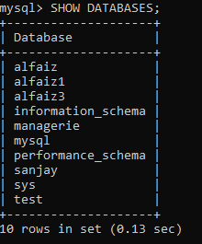

PROGRAM NO:34 DATE: 15/11/26
#PYTHON INTERFACE WITH MYSQL
#INSERTING AND DISPLAYING RECORDS
import mysql.connector as tor
a=tor.connect(host='localhost',user='root',password='12345678',database='test')
b=a.cursor()
def create():
y=input('y/n:')
while y=='y':
Rollno=int(input("Enter Roll Number:"))
Name=input("Enter Student Name:")
Marks=float(input("Enter Student Marks:"))
Grade=input("Enter Student Grade:")
Section=input("Enter Student Section:")
Project=input("Enter Student Project:")
Q="INSERT INTO STUDENT VALUES({},'{}',{},'{}','{}','{}')".format(Rollno,Name,Marks,Grade,Section,Project)
b.execute(Q)
a.commit()
print("Record Stored Successfully")
y=input("Do you want to add another student details(y/n):")
create()
Q="SELECT * FROM STUDENT"
b.execute(Q)
data=b.fetchall()
for i in data:
print(i)
a.close()

OUTPUT
Enter Roll Number:1
Enter Student Name:Anu
Enter Student Marks:85.5
Enter Student Grade:A
Enter Student Section:A
Enter Student Project:Python
Record Stored Successfully
Do you want to add another student details(y/n):y
Enter Roll Number:2
Enter Student Name:Rahul
Enter Student Marks:78
Enter Student Grade:B
Enter Student Section:B
Enter Student Project:MySQL
Do you want to add another student details(y/n):y
Enter Roll Number:3
Enter Student Name:Meera
Enter Student Marks:92
Enter Student Grade:A+
Enter Student Section:A
Enter Student Project:Java
Record Stored Successfully
Do you want to add another student details(y/n):n
(1, 'Anu', 85.5, 'A', 'A', 'Python')
(2, 'Rahul', 78.0, 'B', 'B', 'MySQL')
(3, 'Meera', 92.0, 'A+', 'A', 'Java')
PROGRAM NO: 35 DATE: 17/11/26
#PYTHON INTERFACE WITH MYSQL
# SEARCH AND DISPLAYING RECORDS
import mysql.connector as tor
a=tor.connect(host='localhost',user='root',password='12345678',database='test')
b=a.cursor()
def find():
y=input('y/n:')
while y=='y':
Rollno=int(input("Enter Roll Number to search:"))
Q="SELECT * FROM STUDENT WHERE Rollno={}".format(Rollno)
b.execute(Q)
data=b.fetchall()
for i in data:
print(i)
a.close()
find()

OUTPUT
y/n: y
Enter Roll Number to search: 103
(103, 'SIMRAN', 81, 'A', 'B', 'EVALUATED', 'mary matha')

PROGRAM NO: 36 DATE: 19/11/26
#PYTHON INTERFACE WITH MYSQL
# UPDATING RECORDS
import mysql.connector as tor
a = tor.connect(host='localhost', user='root',password='12345678', database='test')
b = a.cursor()
y = input('y/n: ')
while y == 'y':
Rollno = int(input("Enter Roll Number to update: "))
Marks = float(input("Enter New Marks: "))
Grade = input("Enter New Grade: ")
Q = "UPDATE STUDENT SETMARK={},GRADE='{}'WHEREROLL_NO={}".format(
Marks, Grade, Rollno )
b.execute(Q)
a.commit()
print("Record Updated Successfully")
y = input("Do you want to update another record? y/n: ")
# Display all records
b.execute("SELECT * FROM STUDENT")
for row in b.fetchall():
print(row)
b.close()
a.close()

OUTPUT
y/n: y
Enter Roll Number to update: 101
Enter New Marks: 85
Enter New Grade: A
Record Updated Successfully
Do you want to update another record? y/n: n
(101, 'RUHANI', 85.0, 'A', 'A', 'PENDING', 'mary matha')
(102, 'GEORGE', 71.0, 'B', 'A', 'SUBMITTED', 'mary matha')
(103, 'SIMRAN', 81.0, 'A', 'B', 'EVALUATED', 'mary matha')
(104, 'ALI', 61.0, 'B', 'C', 'ASSIGNED', 'mary matha')
(105, 'KUSHAL', 52.0, 'C', 'C', 'EVALUATED', 'mary matha')
(106, 'ARSIYA', 92.0, 'A', 'B', 'SUBMITTED', 'mary matha')
(107, 'RAUNAK', 100.0, 'F', 'B', 'SUBMITTED', 'mary matha')

PROGRAM NO: 37 DATE: 23/11/26
#PYTHON INTERFACE WITH MYSQL
# DELETE THE RECODS FROM THE TABLE

import mysql.connector as tor
a=tor.connect(host='localhost',user='root',password='12345678',database='test')
b=a.cursor()
def delete():
Rollno=int(input("Enter Roll Number to delete:"))
Q="DELETE FROM STUDENT WHERE Rollno={}".format(Rollno)
b.execute(Q)
a.commit()
print("Record Deleted Successfully")
a.close()
delete()

OUTPUT
Enter Roll Number to delete: 104
Record Deleted Successfully

PROGRAM NO: 38 DATE: 25/11/26
#PYTHON INTERFACE WITH MYSQL
# DELETE DATABASE AND TABLE

import mysql.connector as tor
my=tor.connect(host='localhost',user='root',password='12345678',database='test')
a=my.cursor()
print("""ENTER 1 TO DELETE TABLE:
ENTER 2 TO DELETE DATABASE:""")
b=input('choose:')
if b==1:
table()
if b==2:
database()
def table():
a=input('Enter name of table to delete:')
q="drop table '{}'".format(k)
my.execute(q)
my.commit()
my.close()
def database():
a=input('Enter name of database to delete:')
q="drop database '{}'".format(k)
my.execute(q)
my.commit()
my.close()
def show():
import mysql.connector
conn = mysql.connector.connect(
host="localhost", user="root",password="12345678",database="test")
cursor = conn.cursor()
cursor.execute("SELECT * FROM students")
for row in cursor.fetchall():
print(row)
cursor.close()
conn.close()
show()
OUTPUT

ENTER 1 TO DELETE TABLE
ENTER 2 TO DELETE DATABASE
Choose: 1
Enter name of table to delete: STUDENT
Table Deleted Successfully

Existing Tables:
EMPLOYEE
MARKS

SQL COMMANDS

PROGRAM NO:39 DATE: 5/12/26
SQL COMMANDS EXERCISE -1
#TO WRITE QUERIES FOR THE FOLLOWING QUESTIONS BASED ON THE GIVEN TABLE
ROLLNO | NAME | GENDER | AGE | DEPT | DOA | FEES
1 | ARUN | M | 24 | COMPUTER | 1997-01-10 | 120.00
2 | ANKIT | M | 21 | HISTORY | 1998-03-24 | 200.00
3 | ANU | F | 20 | HINDI | 1996-12-12 | 300.00
4 | BALA | M | 19 | NULL | 1999-07-01 | 400.00
5 | CHARAN | M | 18 | HINDI | 1997-09-05 | 250.00
6 | DEEPA | F | 19 | HISTORY | 1997-06-27 | 300.00
7 | DINESH | M | 22 | COMPUTER | 1997-02-25 | 210.00
8 | USHA | F | 23 | NULL | 1997-07-31 | 200.00

A)WRITE A QUERY TO CREATE A NEW DATABASE IN THE NAME OF “sanjay”.

CREATE DATABASE sanjay;
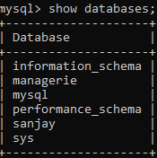

B) WRITE A QUERY TO CREATE THE ABOVE TABLE CALLED “sanjay”

USE sanjay;

C) VIEW THE STRUCTURE OF THE TABLE MYDATABASE1
DESC MYDATABASE1;

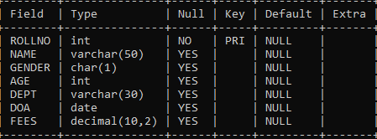

D) INSERT THE GIVEN DATA INTO TABLE MYDATABASE1

INSERT INTO MYDATABASE1
(ROLL_NO, NAME, GENDER, AGE, DEPT, DOB, FEES)
VALUES
(1, 'ARUN', 'M', 24, 'COMPUTER', '2007-01-15', 120),
(2, 'ALEN', 'M', 21, 'HISTORY', '2001-09-01', 200),
(3, 'ACHU', 'F', 20, 'HINDI', '1996-04-25', 300),
(4, 'ANU', 'M', 25, 'MALAYALAM', '1995-05-21', 400),
(5, 'CYRIL', 'M', 20, 'ENGLISH', '2000-02-20', 250),
(6, 'DAVID', 'M', 24, 'MATHS', '2000-03-30', 300),
(7, 'ERWIN', 'M', 21, 'COMPUTER', '1999-09-02', 200),
(8, 'NEHA', 'F', 23, NULL, '1997-07-31', 200);
E) SHOWING RECORDS OF THE TABLE MYDATABASE1
SELECT * FROM MYDATABASE1;
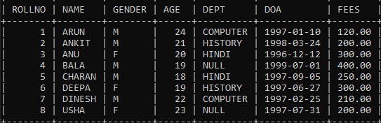

F) QUERY TO DISPLAY THE DETAILS OF FEMALE STUDENTS
SELECT * FROM mydatabase1 where GENDER = 'F';
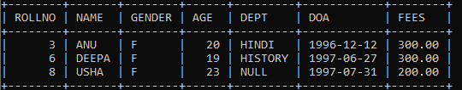

G) QUERY TO DISPLAY THE DETAILS OF YOUNGER STUDENTS FROM THE TABLES
SELECT * FROM mydatabase1 where AGE = ( SELECT MAX(AGE) FROM mydatabase1);

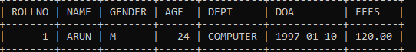

PROGRAM NO:40 DATE: 11/12/26
SQL COMMANDS EXERCISE -2
#TO WRITE QUERIES FOR THE FOLLOWING QUESTIONS BASED ON THE GIVEN TABLE
ROLLNO | NAME | GENDER | AGE | DEPT | DOA | FEES
1 | ARUN | M | 24 | COMPUTER | 1997-01-10 | 120.00
2 | ANKIT | M | 21 | HISTORY | 1998-03-24 | 200.00
3 | ANU | F | 20 | HINDI | 1996-12-12 | 300.00
4 | BALA | M | 19 | NULL | 1999-07-01 | 400.00
5 | CHARAN | M | 18 | HINDI | 1997-09-05 | 250.00
6 | DEEPA | F | 19 | HISTORY | 1997-06-27 | 300.00
7 | DINESH | M | 22 | COMPUTER | 1997-02-25 | 210.00
8 | USHA | F | 23 | NULL | 1997-07-31 | 200.00

- WRITE A QUERY TO ALTER TABLE TO ADD NEW COLLECTION OF TYPE VARCHAR(20)

ALTER TABLE MYDATABASE1 ADD GRADE VARCHAR(20)

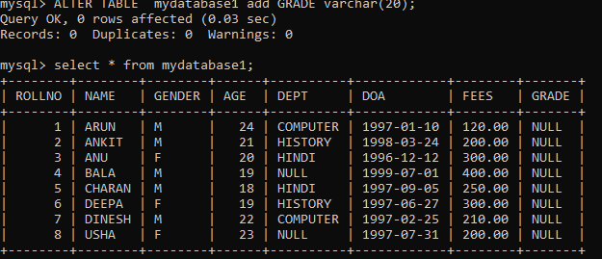

- WRITE A QUERY TO CHANGE FEES OF STUDENT BY 170 WHOSE ROLLNO IS 1.IF THE EXISTING FEES IS LESS THAN 130.
UPDATE MYDATABASE1 SET FEES =170 WHERE ROLLNO =1 AND FEES <130;
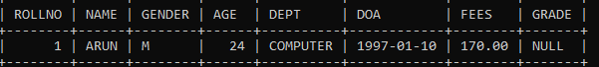

- WRITE A QUERY TO DISPLAY THE DETIALS OF STUDENTS IN ASCENDING ORDER OF NAME
SELECT * FROM MYDATABASE1 ORDER BY NAME ASC;
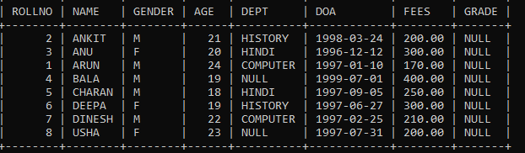

D) WRITE A QUERY TO DELETE THE DETIALS OF ROLLNO=8
DELETE FROM MYDATABASE1 WHERE ROLLNO=8;
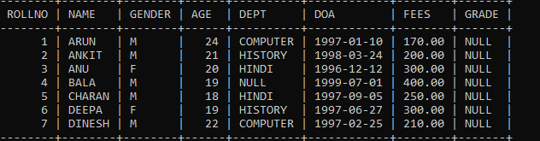

E)WRITE A QUERY TO LIST THE NAME OF FEMALE STUDENTS IN HINDI DEPARTMENT.
SELECT NAME FROM MYDATABASE1 WHERE DEPT='HINDI' AND GENDER ='F';

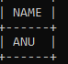

F)DISPLAY THE NAME OF STUDENT END WITH N.
SELECT * FROM MYDATABASE1 WHERE NAME LIKE '%N';

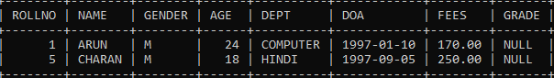

G) DISPLAY THE DETAILS OF STUDENTS WITH FEES LESS THAN 200.
SELECT * FROM MYDATABASE1 WHERE FEES < 200;
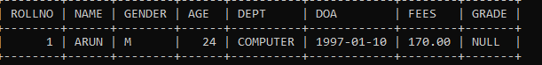

H) DISPLAY THE DETAILS OF A STUDENT WHO BORN AFTER 2000

SELECT * FROM MYDATABASE1 WHERE DOA > '2000-01-01';

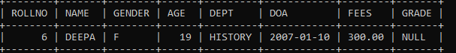

PROGRAM NO: 41 DATE: 16/12/26
SQL COMMANDS EXERCISE -3
#TO WRITE QUERIES FOR THE FOLLOWING QUESTIONS BASED ON THE GIVEN TABLE

EmployeeId | Name | Sales | JobId
E1 | SAMIT SINHA | 1100000 | 102
E2 | VIJAY SINGH TOMAR | 1300000 | 101
E3 | AJAY RAJPAL | 1400000 | 103
E4 | MOHIT RAMNANI | 1250000 | 102
E5 | SHAILJA SINGH | 1450000 | 103

JobId | JobTitle | Salary
101 | President | 200000
102 | Vice President | 125000
103 | Administration Assistant | 80000
104 | Accounting Manager | 70000
105 | Accountant | 65000
106 | Sales Manager | 80000

- TO DISPLAY EMPOLYEE IDS ,NAMES OF EMPLOYEES,JOB IDS WITH CORRESPONDING JOB TITLES
SELECT E.EmployeeId, E.Name, E.JobId, J.JobTitle FROM EMPLOYEE E, JOB J WHERE E.JobId = J.JobId;

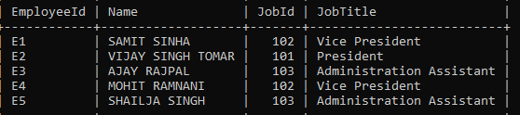

- TO DISPLAY NAMES OF EMPLOYES,SALES AND CORRESPONDING JOB TITLES WHO HAVE ACHIVED SALES MORE THAN 1300000.
SELECT E.Name, E.Sales, J.JobTitle FROM EMPLOYEE E, JOB J WHERE E.JobId = J.JobId AND E.Sales > 1300000;

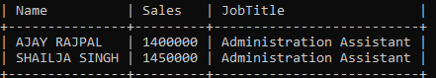

- TO DISPLAY NAMES AND CORRESPONDING JOB TITILES OF THOSE EMPLOYEE WHO HAVE ‘SINGH’ ( ANYWHERE) IN THEIR NAMES.
SELECT E.Name, J.JobTitle FROM EMPLOYEE E, JOB J WHERE E.JobId = J.JobId AND E.Name LIKE '%SINGH%';

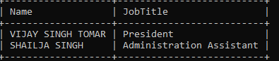

- IDENTIFY FOREIGH KEY IN THE TABLE EMPLOYEE
HERE JOBID IN THE PRIMARY KEY IN EMPLOYEE TABLE AND FOREIGN KEY IN JOB TABLE

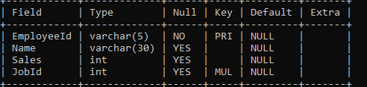

- WRITE A QUERY TO CHANGE THE JOBID TO 104 OF THE EMPLOYEE WITH ID AS E4 IN THE TABLE ‘EMPLOYEE’.
UPDATE EMPLOYEE SET JobId =104 where EmployeeId ='E4';

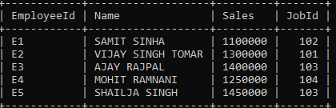

- DISPLAY THE NAME OF THE EMPLOYEE WHO MADE THE HIGHEST SALE.
SELECT Name
FROM Employee
WHERE Sales = (SELECT MAX(Sales) FROM Employee);
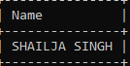

G)DISPlAY THE NAME OF THE EMPLOYEE ACCORDING TO THE SALE IN ASC ORDER.
SELECT Name
FROM Employee
ORDER BY Sales ASC;
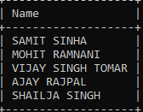

PROGRAM NO:42 DATE: 21/12/26
SQL COMMANDS EXERCISE -4
#TO WRITE QUERIES FOR THE FOLLOWING QUESTIONS BASED ON THE GIVEN TABLE

StoreId | Name | Location | City | NoOfEmp | DateOpened | SalesAmount
S101 | Planetfashion | KarolBagh | Delhi | 7 | 2015-10-16 | 300000
S102 | Trends | NehruNagar | Mumbai | 11 | 2015-08-09 | 400000
S103 | Vogue | Vikas Vihar | Delhi | 10 | 2015-06-27 | 200000
S104 | Superfashion | DefenceColony | Delhi | 8 | 2015-02-18 | 450000
S105 | Rage | Bandra | Mumbai | 5 | 2015-09-22 | 600000

- TO DISPLAY NAME LOCATION,CITY,SALESAMOUNT, OF SOTORE IN DESC ORDER OF SALESAMOUNT.

SELECT Name, Location, City, SalesAmount FROM Store ORDER BY SalesAmount DESC;

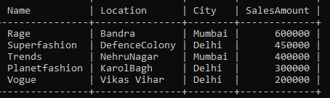

- DISPLAY NAME OF STORE ALONG WITH SALESAMOUNT OF THOSE STORES THAT HAVE ‘FASHION’ ANYWHERE IN THEIR STORE NAME.
SELECT Name, SalesAmount FROM Store WHERE Name LIKE '%Fashion%';

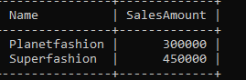

- TO DISPLAY STORE NAMES,LOCATION AND DATE OPENED OF STORES THAT WERE OPENED BEFORE 1ST MAECH 2015

SELECT Name, Location, DateOpened
FROM Store
WHERE DateOpened < '2015-03-01';

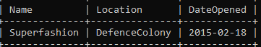

- TO DISPLAY TOTAL SALESAMOUNT OF EACH CITY ALONG WITH CITY NAME.

SELECT City, SUM(SalesAmount) AS Total_SalesAmount FROM Store
GROUP BY City;
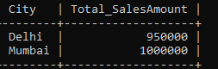
- TO ADD A NEW COLUMN YEAROFSALES.

ALTER TABLE STORE ADD COLUMN YEAROFSALE VARCHAR(50);

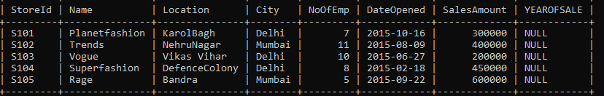

- TO DELETE THE COLUMN NOOFEMP.
ALTER TABLE STORE DROP COLUMN NOOFEMP;

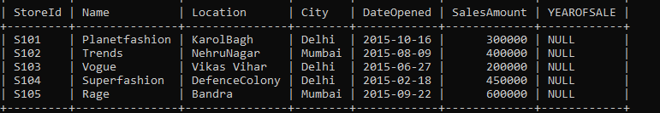

- TO INCREASE THE SALESAMOUNT BY 10% WHERE CITY IS ‘DELHI’.
UPDATE Store SET SalesAmount = SalesAmount * 1.10 WHERE City = 'Delhi';
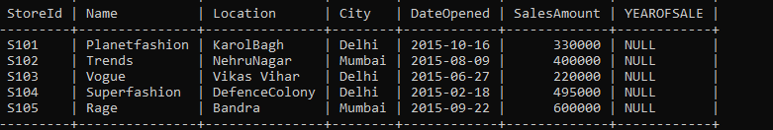

PROGRAM NO:43 DATE: 21/12/26

SQL COMMANDS EXERCISE-5
#TO WRITE QUERIES FOR THE FOLLOWING QUESTIONS BASED ON THE GIVEN TABLE:
UCODE | UNAME | UCOLOR | STOCKDATE
1 | SHIRT | WHITE | 2021-03-31
2 | PANT | BLACK | 2020-01-01
3 | SKIRT | GREY | 2021-02-18
4 | TIE | BLUE | 2019-01-01
5 | SOCKS | BLUE | 2019-03-19
6 | BELT | BLUE | 2017-12-09

UCODE | SIZE | PRICE | COMPANY
1 | M | 500 | RAYMOND
1 | L | 580 | MATTEX
2 | XL | 620 | MATTEX
2 | M | 810 | YASIN
2 | L | 940 | RAYMOND
3 | M | 770 | YASIN
3 | L | 830 | GALIN
4 | S | 150 | MATTEX

A). TO DISPLAY THE AVERAGE PRICE OFF ALL THE UNIFORM OF RAYMOND COMPANY FROM TABLE COST.
SELECT AVG(PRICE) FROM COST WHERE COMPANY='RAYMOND';

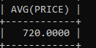

B). TO DISPLAY DETAILS OF ALL THE UNIFORM IN THE UNIFORM TABLE IN DESCENDING ORDER OF STOCKDATE.
SELECT * FROM UNIFORM ORDER BY STOCKDATE DESC;

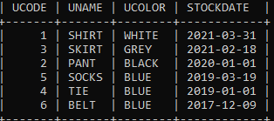

C). TO DISPLAY MAX PRICE AND MIN PRICE OF EACH COMPANY.
SELECT COMPANY,MAX(PRICE),MIN(PRICE) FROM COST GROUP BY COMPANY;
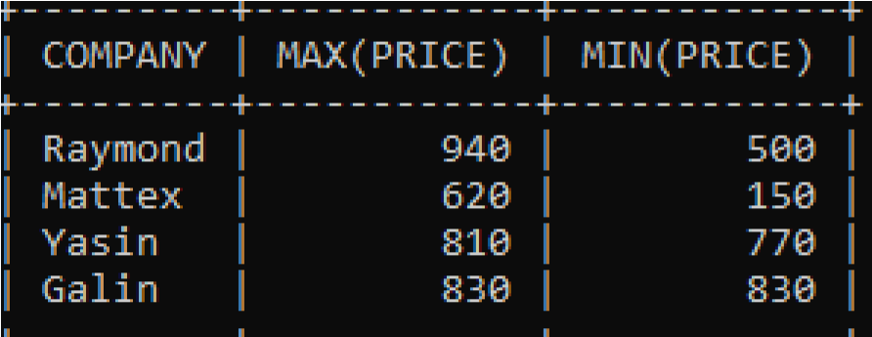
d). TO DISPLAY THE COMPANY WHERE THE NUMBER OF UNIFORM SIZE IS MORE THAN 2.
SELECT COMPANY,COUNT(*)FROM COST GROUP BY COMPANY HAVING
COUNT(*)>2;
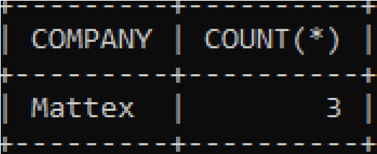
E). TO DISPLAY UCODE,UNAME,UCOLOR,SIZE AND COMPANY OF TABLES UNIFORM AND COST.
SELECT U.UCODE,UNAME,UCOLOR,SIZE,COMPANY FROM UNIFORM U,COST C WHERE U.UCODE=C.UCODE;
